# Report of Homework 1

Yin Chenqiao, student number: 1500015533

## Problem #1

1(a)

First, we should import the data USArrests and have a brief view of the data (L10-11). The output is:

Murder Assault UrbanPop Rape

Alabama 13.2 236 58 21.2

Alaska 10.0 263 48 44.5

Arizona 8.1 294 80 31.0

Arkansas 8.8 190 50 19.5

California 9.0 276 91 40.6

Colorado 7.9 204 78 38.7

Then use the function ggplot to plot the data, and the function geom_point to draw the scatterplot (L12-14). And below is the plot:



We have used these two functions many times, so it’s easy to finish and I don’t need to explain more about the code.

1(b)

We need to add a regression overlay to the plot. It’s also easy by using function geom_smmoth. As a regression line shows the relationship better, I choose to draw a regression line by using the parameter method = 'lm' (L17-19).

Below is the plot:



1(c)

From the regression line we can see that there is a slightly positive relationship between urban population and murder rate. That is, a bigger state may have higher murder rate. Maybe a big state has high cost of security, so criminals have lower cost to murder.

1(d)

We have written similar codes on the class. It may take a little time, but it’s not hard to finish the code by imitation. Like the final map we drew on the class, I changed the color to make it not strange to read (L23-32). Below is the map:



1(e)

The code here may be hard to read because it has been simplified (L35-40). But first I will show the result of the code. The output is:

[1] "california"

So California has the largest urban population.

Then I’ll try to explain my code. We need to find the state which has the largest population, so first we should find the largest population. We can use the code below:

largest.pop = max(choro.1$urbanpop, na.rm = T)

Now we have the largest population (actually, the output is 91). Then we should find which state has that population by using the code below:

largest.state.id = which(choro.1$urbanpop == largest.pop)

Because the return value of which function is the row number of the data, now we still don’t have the name of the state. But we are close to it. To get the name of the state, we need to use the region field in the dataset choro.1.

largest.state = choro.1$region[largest.state.id]

If we run the code above, we can get the output below:

[1] "california" "california" "california" "california" "california" "california"

[7] "california" "california" "california" "california" "california" "california"

…… (omitted some output)

[505] "california" "california" "california" "california" "california" "california"

[511] "california" "california" "california" "california" "california" "california"

This is because the dataset has many pieces of data whose value of field is california. To get only one result, we should use the unique function:

largest.state = unique(choro.1$region[largest.state.id])

Now the output is:

[1] "california"

See we get a unique answer. If we simplify the code above, we can get the code in the source file. Actually they are the same.

Now take a look at the map on murder rates. We can easily find that the dark blue regions and the light blue regions in the two maps are almost the same. It stands for what we find in the regression line, which is, a bigger state has a higher murder rate.

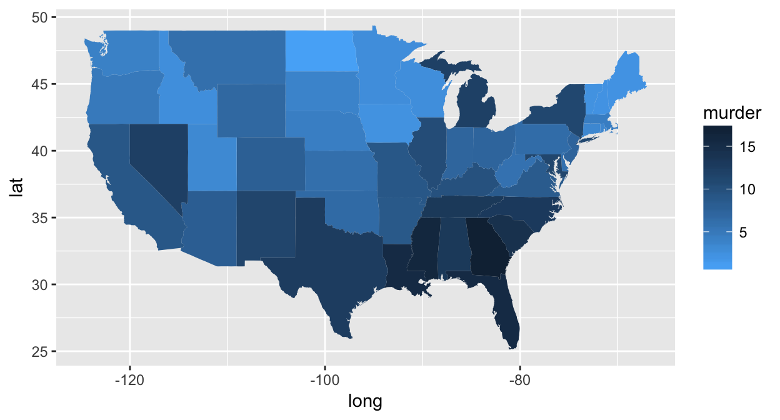

## Problem #2

2(a)

We have already been familiar to the function ggplot and geom_point, so it’s easy to draw the plot below:



2(b)

Now we need to add a regression line. From the scatter plot we can see there are a few points with extreme values. Before we draw the regression line, we should clear the data first. I choose to delete the data out of 3 times of standard deviation (L58-59). I want to simplify the code, but it’s strange that there is an error when I run the code below:

unemp.sub = subset(unemp, subset = pop < (mean(unemp$pop) + 3*sd(unemp$pop)))

Anyway, it’s still fine to run the original code.

After clearing the data, we can draw the regression line using the geom_smooth function, which we have also been familiar to. Below is the plot:



2(c)

There is a so slightly positive relationship that I don’t think it’s statistically significant. So I think there is no relationship between population size and unemployment rate.

2(d)

We have written similar code on the class, so it isn’t hard to write the code. Below is the map.



2(e)

I use similar code as in 1(e). The output is:

[1] "california,los angeles"

Because these lines of code are more complex, I’ll explain them again. We need to find the county with the largest population. First, we need to find the row number of the county with the largest population by using the code below:

largest.county.id = which(unemp$pop == max(unemp$pop, na.rm = T))

If we want to get the name of the county, we should use the field polyname in the dataset county.fips. To create an relationship between the dataset unemp and county.fips, note that the two database have a same field fips, which maybe a kind of id of the county. To get the fip of the county with the largest population, use the code below:

largest.county.fip = unemp$fips[largest.county.id]

Then we need to find that fip in the dataset county.fips. Again we should use which function:

largest.county.id2 = which(county.fips$fips == largest.county.fip)

Now we can get the name of that county:

largest.county = county.fips$polyname[largest.county.id2]

Again, if we simplify these lines of code, we can get the code in the source file.

Now take a look at the map on unemployment rates. We can find that the red regions and the blue regions in the two maps are very similar. So if we just see the map, maybe we can conclude that there is a positive relationship between population size and unemployment level.

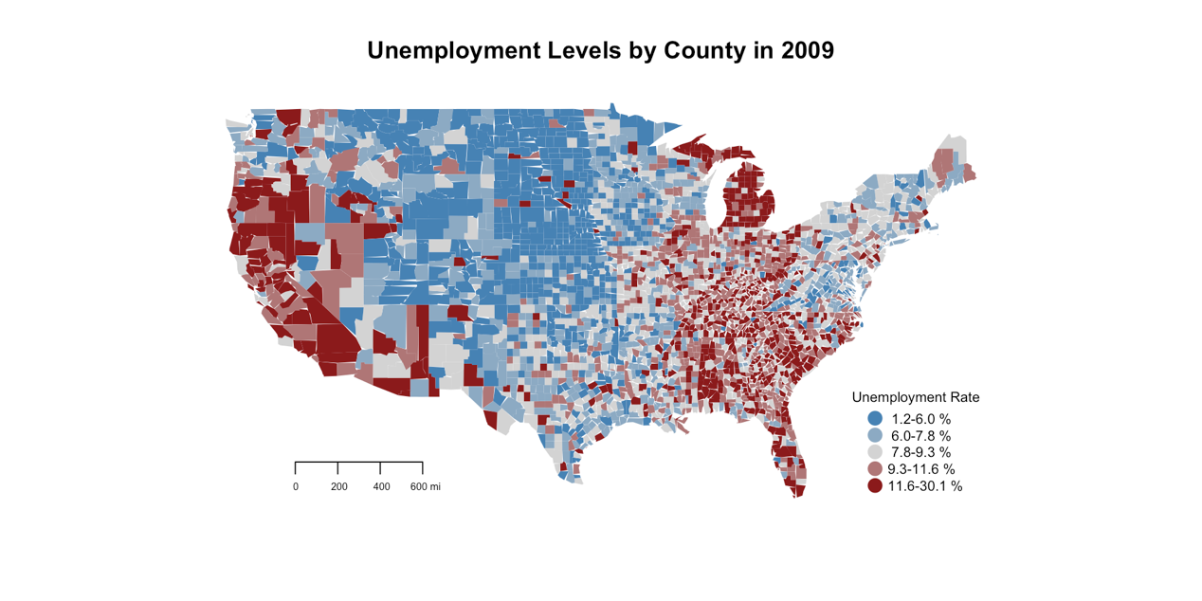

## Problem #3

3(a)

Below is World Bank WDI website.



3(b)

I use WDIsearch function to search. There are 142 indicators about interest, below are some of them. I choose the indicator FR.INR.DPST, which means the deposit interest rate (%).

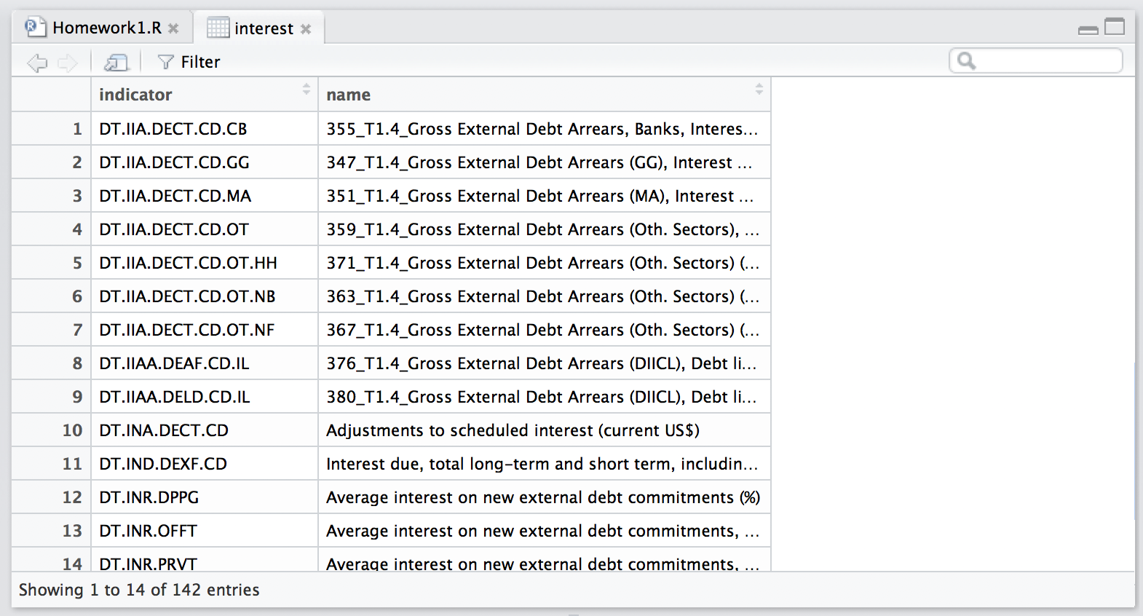

3(c)

We need to choose another 1 or 2 countries, so it’s necessary to know the short of the countries. First, use the field country in the dataset WDI_data to browse the country names and the short of country names (L106-107):

country = WDI_data$country #Browse the country names

View(country)

I choose Australia and Brazil to analyze their data. It’s easy to download the data by imitating the code on the class.

3(d)

Now we need to plot line graphs for each country. Besides using ggplot and geom_line function, we also need to use facet_grid function. It’s strange that the data of India and US is missing, but I have double checked it by viewing the website and find that WDI does not have the data.

From the plot we can see that the deposit interest rate vary among countries. The deposit interest rate in Brazil is dramatically high, and the deposit interest rate in Japan is relatively low (close to 0). The deposit interest rate in Australia and China is stable and appropriate.



3(e)

To prevent potential error when using the data with missing values, first I let all the missing values be zero:

data.interest$FR.INR.DPST[which(is.na(data.interest$FR.INR.DPST) == 1)] = 0

Then use ddply function to get the average interest of each country:

AggrData = ddply(data.interest, .(country), summarize,

InterestAvg = mean(FR.INR.DPST, na.rm = T))

It’s easy to plot by using ggplot and geom_bar function, below is the plot:



We can see the interest rate in Brazil is very high, and the interest rate in Japan is close to 0. The interest rate in Australia and China falls in the middle.

## Problem #4

4(a)

We need to download the data NY.GDP.PCAP.KD.ZG and FR.INR.DPST of all available countries in 2010. It’s easy by using WDI function and change some of the parameters.

4(b)

Now plot again. I don’t think it’s necessary to explain the code. Below is the plot:



We can see that there isn’t any relationship between interest rate and GDP growth.

4(c)

To finish the problem, we need to imitate the code on the class. We don’t know the min and the max of deposit interest rate, so to make each country colored, we need to use min and max function. Below is the map. Because there are some missing values, some countries remain white.

